TECHNICAL PROJECT REPORT

# Title of Invention / Project:

# Team Members / Inventors:

|  |  |  |  |  |  |
| --- | --- | --- | --- | --- | --- |
| **S. No.** | **Name** | **Department** | **Designation** | **Mobile** | **E-Mail** |
| 1. | Dev Karan Joshi | CSE AIML1 | Student | 9780828334 | Devtopper@gmail.com |
| 2. | Rhythm Gupta | CSE AIML1 | Student | 7710638081 | CU18BCS6005@gmail.com |
| 3. | Mrigakshi | CSE AIML1 | Student | 8968674620 | Mrigakshi30@gmail.com |
| 4 | Khushal Thakur | ECE | Mentor | 9646030764 | khushal.thakur@cumail.in |
| 5. | Anshul Sharma | ECE | Mentor | 9478697475 | anshulsharma.ece@cumail.in |
| 6. | Kiran Jot Singh | ECE | Mentor | 9463909689 | kiranjotsingh.ece@cumal.in |
| 7. | Divneet Singh Kapoor | ECE | Mentor | 9878422653 | divneet.ece@cumail.in |

Section – 1 (IPR Related)

# Brief Abstract

An alarm clock should be reliable and versatile, letting you customize your wake-up experience without letting you down

* Neither of us really wakes up at our destined time .We keep snoozing the alarm until we run out of time. Even after buzzing off our alarm we tend to feel sleepy.
* By **hitting the snooze button**, **you**'re interfering with your body's natural wake mechanisms, which actually sets **you** up for more exhaustion during the day ahead. ... "When your **alarm** goes off again, your body and brain are confused, resulting in that foggy feeling called sleep inertia.
* Additional modifications that can cater to improved solution

1. Addition of memory game to give our mind some time to wake up

* designed to look like a memory game , this alarm clock gives you a memory test in the morning when it sounds off. In order to cease the alarm, you need to press the correct order of flashing leds in order to have the alarm shut off…
* This alarm clock uses ardruino , buzzer , jumper wires , resistor, led, buttons , enclosed in an attractive box
* Timer feature will allow user to enter countdown time .
* When alarm will buzz, Leds will flash in certain order. User has to match that led pattern so that alarm stops. Incase user fails to match led pattern snooze option is provided . There’s a snooze button for those mornings when you need some extra sleep. There after leds will reflash , so that alarm can be turned off. The LED display is nice and easy to read,
* This simple memory game forces user to wake up completely.

Although snooze button is also provided so that user don’t get irritated by this new feature.

Our alarm clock incorporated all functions of modern alarm clock.

Additional features of memory game:

* improve concentration
* train visual memory
* increase short term memory
* increase attention to detail
* improve the ability to find similarities and differences in objects
* help to classify objects that are grouped by similar traits

Designed to fit anywhere in your home,this product is really worth buying

# Existing state-of-the-art and Drawbacks in existing state-of-the-art

|  |  |  |
| --- | --- | --- |
| **S. No.** | **Existing state of art** | **Drawbacks in existing state of art** |
| 1 | Usual alarm clock | **Snoozing alarm** can add to your stress levels by getting your adrenaline rushing |
| 2 | Normal alarm clock | Usual alarm clocks are boring and we are used to snoozing alarms |
| 3 | Usual alarm clock | Incapable of making people really wake up |

# Additional modifications that WE can propose to improve upon drawbacks

1. If you use the clock regularly, it will provides your "iWake coefficient," which basically calculates your statistics of minutes taken to wake up, number of [alarm clocks](https://mashable.com/category/alarm-clocks/) and wrong answers all into

# wake up to the radio or to an alarm that gets louder over time

1. You can set up clock to respond to your voice commands, or manage devices using the touchscreen
2. Feature of gentle glow and natural sound effects rather than incessant beeping to get you out of bed.
3. clock can project the time onto the ceiling, the curtains, or just about any other surface, using the 180-degree swivel
4. The clock is ultra-compact

Advantages:

* These featueres will make clock interesting
* People from all ages will love to use this clock at least once
* All modern innovations will be incorporated in this clock

# Block Diagram

Section – 2 (Real Project)

# Materials

* Soldering wire
* Soldering rod
* Box for outer design
* Feviquick
* Laptop
* Ardruino
* Resistor
* Jumper wire
* Buttons
* Leds
* Connector wire
* Lcd
* Breadboard

# Circuit Diagram

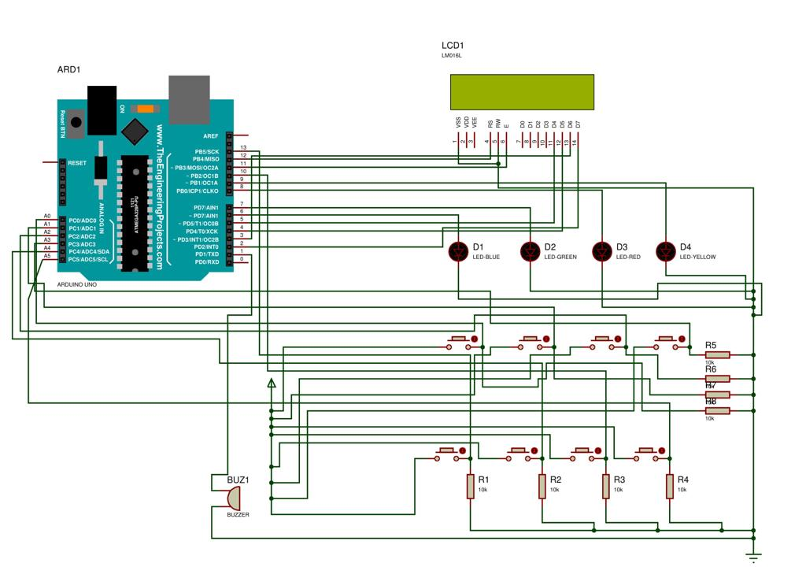

# Steps of Circuit Completion

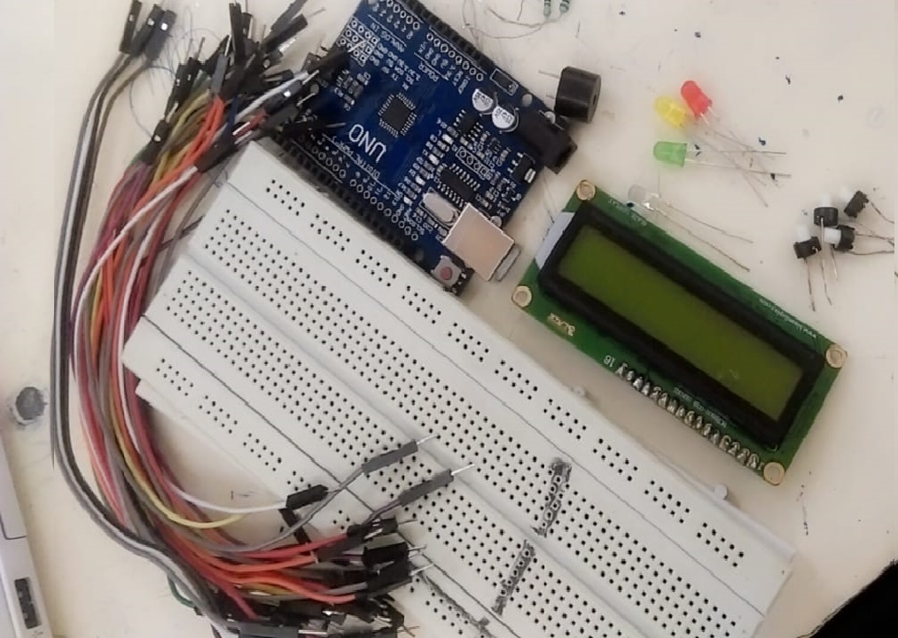

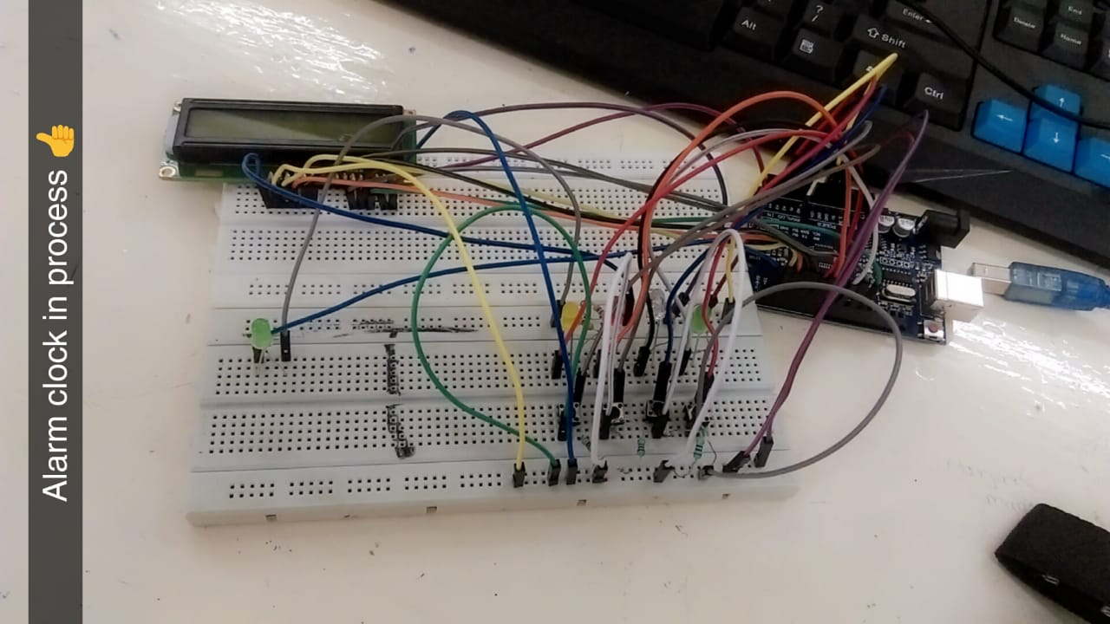

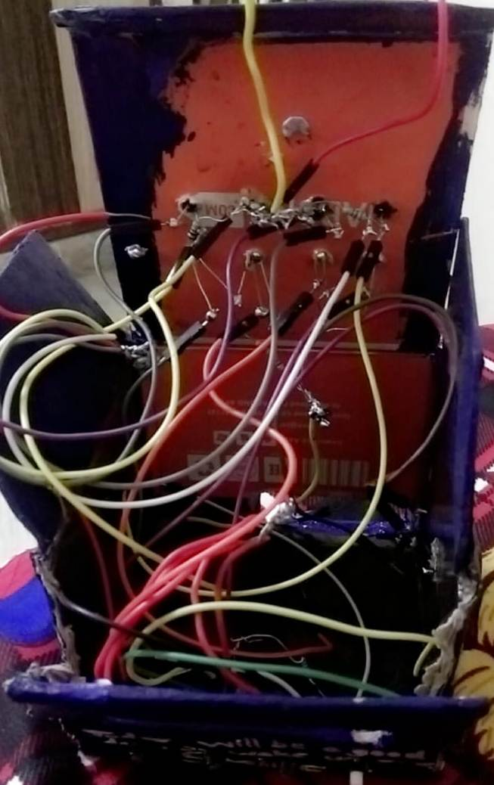

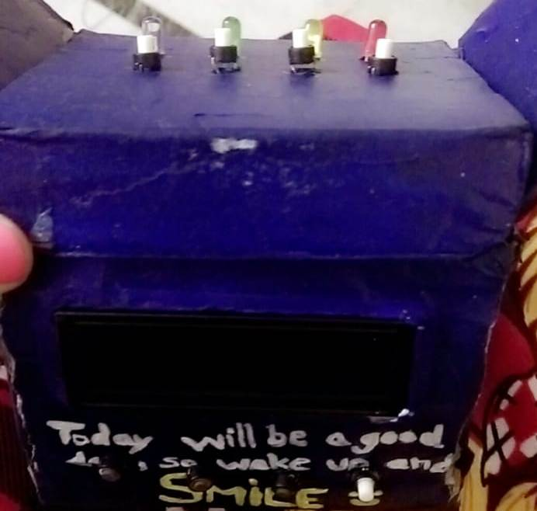

# Program Code

https://github.com/BeeeGroup/Beee-Project